MAJOR PROJECT ON

FURNITURE E-COMMERCE STORE BASED ON AUGMENTED REALITY

Submitted in partial fulfilment of the requirements of the degree of

(Bachelor of Engineering)

Supervised by **Prof. Bhavna Arora**

Under – taken by

**Syamantak**

**N.Dhavle**

**Chaudhary**

**Mohammed Qais**

**Khan Mohd Saif**

**Tabarakallah**



**Computer Engineering**

**Atharva College of Engineering**

**(2020-21)**

**DECLARATION**

I declare that this written submission represents my ideas in my own words and where others' ideas or words have been included, I have adequately cited and referenced the original sources. I also declare that I have adhered to all principles of academic honesty and integrity and have not misrepresented or fabricated or falsified any idea/data/fact/source in my submission. I understand that any violation of the above will be cause for disciplinary action by the Institute and can also evoke penal action from the sources which have thus not been properly cited or from whom proper permission has not been taken when needed.

-----------------------------------------

-----------------------------------------

-----------------------------------------

**Date: (Name and Signature of Students)**

**Project Report Approval for B.E.**

This project report entitled **“*Furniture e-commerce store based on Augmented Reality*”** by ***Syamantak Dhavle, Mohammed Qais & Khan Mohd Saif Tabarkullah*** is approved for the degree of  ***Bachelor of Engineering in Computer Engineering.***

Internal Examiner

---------------------------------------------

---------------------------------------------

External Examiner

---------------------------------------------

---------------------------------------------

Date: __________

Place: __________

College Seal



**AET’S**

**ATHARVA COLLEGE OF ENGINEERING**

CERTIFICATE

*This is to certify that*

**Syamantak N. Dhavle**

**Mohammed Qais**

**Khan Mohd Saif Tabarkullah**

*Have satisfactorily completed the requirements of the B.E Project Report*

On

**“FURNITURE E-COMMERCE STORE BASED ON AUGMENTED REALITY”**

*As prescribed by the* ***University of Mumbai*** *Under the guidance of*

Guide

**Prof. Bhavna Arora**

**Prof. Bhavna Arora Dr. Suvarna Pansambal Dr. S.P.Kallurkar**

**Project Coordinator Head(Computer Engineering) Principal**

**(April 2021) College Seal Date:**

**ACKNOWLEDGEMENT**

We would like to thank our project guide **Prof. Bhavna Arora** for her enormous cooperation and guidance. We have no words to express our gratitude for a person who wholeheartedly supported the project and gave freely of her valuable time while making this project. All the inputs given by her found a place in the project.

We would also like to thank **Dr. Suvarna Pansambal** (Head, Computer Engineering), for providing us technical guidance which was very helpful to us and made this a success. She has always been a source of inspiration for us. It was a great experience learning under such a highly innovative, enthusiastic and hardworking professor. We are also thankful to our principal **Dr. S.P. Kallurkar**, project coordinators and all the staff members of the Computer Department who have provided us various facilities and guided us throughout to develop this project idea. Finally, we would like to thank the teachers of our college and friends who guided and helped us while we were working on this project idea.

**ABSTRACT**

Electronic Commerce is a process of doing business through computer networks. A person sitting on his chair in front of a computer can access all the facilities of the Internet to buy or sell the products. Unlike traditional commerce that is carried out physically with effort of a person to go & get products, ecommerce has made it easier for humans to reduce physical work and to save time. E-Commerce which was started in early 1990’s has taken a great leap in the world of computers, but the fact that has hindered the growth of e-commerce is security. Security is the challenge facing e-commerce today & there is still a lot of advancement made in the field of security. The main advantage of e-commerce over traditional commerce is the user can browse online shops, compare prices and order merchandise sitting at home on their PC. For increasing the use of e-commerce in developing countries the B2B e-commerce is implemented for improving access to global markets for firms in developing countries. For a developing country advancement in the field of e-commerce is essential. The research strategy shows the importance of e-commerce in developing countries for business applications.

**INDEX**

|  |  |  |
| --- | --- | --- |
| **Sr. No.** | **Contents** | **Page No.** |
| 1 | Introduction | 11 |
| 1.1 | Need and Motivation | 12 |
| 1.2 | Basic Concept | 12 |
| 1.3 | Applications | 12 |
| 1.4 | Market Potential and Competitive advantages | 12 |
| 2 | Review of Literature | 13 |
| 3 | Report on the Present Investigation | 16 |
| 4 | Aim and Objectives | 17 |
| 5 | Problem Statement. | 18 |
| 6 | Developed System | 19 |
| 7 | Requirement Analysis | 24 |
| 7.1 | Functional Requirement | 24 |
| 7.2 | Non-Functional Requirement | 24 |
| 8 | Scope and Feasibility | 25 |
| 9 | Methodology | 27 |
| 10 | Design Details | 29 |
| 10.1 | Context Level diagram | 29 |
| 10.2 | DFD Diagram | 30 |
| 10.3 | Sequence Diagram | 31 |
| 10.4 | E-R Diagram | 32 |
| 10.5 | Database Realtime DB Design | 33 |
| 10.6 | Database Storage Design | 34 |
| 11 | Implementation Plan | 35 |
| 11.1 | Hardware Requirements | 35 |
| 11.2 | Software Requirements | 35 |
| 11.3 | Pseudo Code | 36 |
| 11.5 | Simulation & Working Environment | 41 |
| 11.6 | Gantt Chart | 42 |
| 12 | Testing | 43 |
| 12.1 | Verification Testing | 43 |
| 12.2 | Test Cases | 43 |
| 13 | Result Analysis | 46 |
| 14 | Advantages & Limitations | 48 |
| 15 | Applications & Future Enhancements | 49 |
| 16 | Conclusion | 50 |
| 17 | Literature Cited | 51 |
| 18 | Appendix | 52 |
| 19 | Paper Details | 53 |

**LIST OF FIGURES**

|  |  |  |
| --- | --- | --- |
| **Figure No.** | **Name of Figure** | **Page No.** |
| 6.0 | System Representation Flowchart | 20 |
| 6.1 | User Block Diagram | 21 |
| 6.2 | Admin Block Diagram | 22 |
| 6.3 | System Database Representation | 23 |
| 10.1 | Context Level Diagram | 30 |
| 10.2 | Data Flow Diagram | 31 |
| 10.3 | Sequence Diagram | 32 |
| 10.4 | Entity Relation Diagram | 33 |
| 10.5 | Database Design | 34 |
| 10.6 | Database Storage Design | 35 |
| 11.1 | Working Environment | 42 |
| 11.2 | Gantt Chart | 43 |

**LIST OF TABLES**

|  |  |  |
| --- | --- | --- |
| **Table No.** | **Name of Table** | **Page No.** |
| 1 | Registration Test | 44 |
| 2 | Login Test | 45 |
| 3 | Data Get Request Test | 45 |
| 4 | Data Put Request Test | 46 |
| 5 | Ar Model Test | 46 |

**1. INTRODUCTION**

* The modern home decor and furniture lessens your stress after spending with a hectic schedule at the office. As vast changes have occurred in the furniture world, many innovative startups are accommodating to the huge demand.
* The online marketplace of India is expected to grow to $14.5 billion (Rs 88,921 crore), and online furniture share of retail is likely to go up by 2021.
* In the beginning, except a few organized players like Home Stop, and HomeTown; none other brands in the furniture retail space have controlled to create a large chain of stores. But, a group of online furniture marketers has come out in the last few years, providing new business models for a company which is certain to grow as India’s middle-class broadens and spending hikes.
* Now, platforms like Pepperfry, Urban Ladder, and FabFurnish have become the most successful eCommerce portals of India as they drive the latest market and assisting people to furnish their homes.

1.1 Need and motivation

There’s a definite need for a technical solution for this problem since the furniture e-commerce industry, as of now, appears to be growing but soon there will be a need for a breakthrough in technology which can replace the touch and feel factor involved for the customers while buying furniture in order to reduce their hesitation while buying such high ticket and larger-sized products online.

Motivation for developing an application like this is to introduce a new technology factor to the already existing e-commerce platforms, which due to the widespread adoption of e-commerce are becoming increasingly common.

1.2 Basic Concept

The basic concept is to build an android e-commerce application with AR functionality. Our goal is to build an app which will provide the customers with an option to check the eligibility of a certain product with their needed specifications, which will involve factors such as dimensions & colour schemes.

1.3 Applications

1. Prospective furniture customers can use this application to gain more insight towards the actual product description.

2. Existing Furniture e-commerce websites & applications can include this technology to boost sales.

3. The technology can be further extended to be used in other industries such as textiles, electronics etc.

1.4 Market potential and Competitive advantages

This product has a range of applications across various industries, which gives it a competitive advantage over the traditional furniture stores. Since the application uses AR as a tool to provide a better shopping experience to customers, it should be accepted widely by the market. Moreover, since the other shopping apps do not have a functionality that is as optimum as this app, it provides us with yet another competitive advantage.

**2. REVIEW OF LITERATURE**

1. ARKit and ARCore in serve to augmented reality [1]

In this paper we have seen the basic understanding about the open-source libraries to be used in building this project, their main features and functionalities for a better implementation in the real world.

2. “Mobile Augmented Reality Survey: FromWhere We Are to Where We Go –IEEE Access” [2]

This paper introduces the concept of MAR (Mobile Augmented Reality) and provides the basic understanding about the same. It also provides the reader with the categorization of the application fields together with some representative examples. It also introduces the reader to the user interface and experience in MAR applications and continues to describe the core system components of the MAR systems.

3. E-commerce Smartphone Application ((IJACSA) International Journal of Advanced Computer Science and Applications,)[3]

This paper provides a new perspective on the types of applications that can be used for e-commerce. It describes and analyses device requirements, provides a review of important aspects of mobile devices that can use such applications and the requirements of websites designed for m-commerce. The design and security aspects of mobile devices are also investigated. As an alternative to existing m-commerce applications, this paper also investigates the characteristics and potential of the PhoneGap cross-mobile platform application

4. ‘‘Creating open source repository of 3D models of laboratory equipments using Blender” IEEE-2010

In this paper we are provided with the key design goals and are presented a methodology to create a repository of 3D models. This methodology can be used to create a significant number of models in Blender in less time. These models can be downloaded and directly used by anyone. Anyone can use this methodology to create their own model repository.



5. “Capabilities of ARCore and ARKit Platforms for AR/VR Applications” - International Conference on Dependability and Complex Systems. In this paper ARCore and ARkit capabilities are scrutinized and compared. Authors establish comparison criteria for both platforms, provide the example of test applications and results of comparison tests. Obtained results can be a help in choosing the right framework to speed up prototyping and development of modern AR/VR applications. This paper consists of a comprehensive comparison of said new frameworks in the following respects: general performance (CPU/memory use), mapping of planes on various surface types, influence of light and movement on mapping quality etc.

6. “The Use of ARCore Technology for Online Control Simulations” IEEE 2020

The paper describes an educational mobile application that controls the 3D model of towercopter using augmented reality for smartphones. The app is developed using the ARCore technology that allows insertion of 3D objects into a real space via smartphone or tablet. The application serves as a simple guide for a real device which is placed in a laboratory and enables to create simulations based on user input data. Users can set their own controller parameters into the predefined control structures.

7. “Android Application Development using Android Studio and PHP Framework” [5]

In this paper “Android Application Development using Android Studio and PHP Framework” The author described that this era is very great and exciting for mobile developers. Android supplies a well-off application structure that permits you to develop imaginative applications and amusements for android cell phones utilizing Java dialect condition. Android proposes a brought together approach for application advancement on cell phones which implies that engineers require production for Android interfaces, and their applications ought to have the capacity to keep running on various gadgets controlled by Android.

8. “Web AR: A Promising Future for Mobile Augmented Reality—State of the Art, Challenges, and Insights” IEEE 2019

This paper differentiates between hardware-based mobile AR and app-based Mobile AR. It describes how hardware-based Mobile AR implementation is known to be costly and lacks flexibility, while the App-based one requires additional downloading and installation in advance and is inconvenient for cross-platform deployment. It provides the advantages of Web-Based AR implementation than hardware based AR by providing information that webAR is a lightweight and cross-platform service provisioning platform.

9. “Systematic review and meta-analysis of augmented reality in medicine, retail, and games” Springer 2020

This paper presents a detailed review of the applications of augmented reality (AR) in three important fields where AR use is currently increasing. The main focus of this paper was to highlight how AR improves and enhances the user experience in entertainment, medicine, and retail. The authors briefly introduce the topic of AR and discuss its differences from virtual reality. They also explain the software and hardware technologies required for implementing an AR system and the different types of displays required for enhancing the user experience.

10. “Research on Development of Android Applications” IEEE 2011

This paper introduces the Android platform and the features of Android applications, giving a detailed description of the Android application framework from the perspective of developers. A simple music player is provided as an example to illustrate the basic working processes of Android application components. This paper provides the required insight to understand the operation mechanism of Android applications to help develop applications on the Android platform.

**3. REPORT ON PRESENT INVESTIGATION**

There are multiple existing applications based on furniture e-commerce like UrbanLadder, Homecentre & Pepperfry. For this particular study, we will analyze the Pepperfry application.

Features

Features of this application are -

* Sign up/Login with social media websites as well as phone number verification.
* Decent user interface.
* Furniture products are well categorized.
* Multiple product images.
* 2d Product view in AR.

General working of the current system -

The end user has to download the application from google play store/Apple app store. Upon opening the application for the first time, it requests login information and provides the user the option to register their account if they haven’t already registered. Upon successful login, the application displays categories of furniture and the user can select the product colours, product images and can even check a 2d model of the product with their ar enabled device cameras.

Limitations

1. 2D representation of the product does not offer a comprehensive idea of the product. 2. Representation of the product in a 2D manner in AR feels overall cheap.

3. Products delivered may be different from the ones in the image as they are displayed in a fancy manner in the images.

4. High prices of the products makes the customer hesitant while completing checkout.

5. High probability of product returns.

6. The problem described in point 2 might also cause the brand image of any furniture store to be tarnished.

**4. AIM AND OBJECTIVES**

4.1 Aim

Our aim is to create the most realistic rendition of the furniture products present in the e-commerce store. We plan to import the objects created to Android studio and create an app which includes an e-commerce store with AR functionality. This app will provide users with a more accurate representation of the said products and will reduce the rate of returns, thereby saving shipping costs. It also provides the user with a substitute (to a certain degree) for the touch and feel aspect while buying furniture, which also increases their trust in the store.

4.2 Objectives-

* Use of this application will enable the user to visualize how the furniture would look in the real world, offering preview of furniture in one’s real environment.
* By the usage of this application, the furniture sellers can win competitive edge in the market.
* It also aims to prevent revenue loss to the business, spoilt brand image of the store, customer attrition and deterioration of stakeholders’ interests as the customers can try visualizations of furniture placements in the available space before purchasing them.
* It aims to put the sentence “What you see is what you get” in practice.

**5. PROBLEM STATEMENT**

Purchasing products for interior design is a challenging task. The problem is concerned with the fact that the product cannot be put into its place before it is purchased. Customers may wonder how the furniture would look in its tentative place, People end up buying furniture with incorrect dimensions, inaccurate colours or different designs from the ones that they see in the product images. This creates a problem for customers as returns in such online stores is also a hassle and generally a bad idea, since it is not easy to ship furniture due to the high prices involved in shipping. Visualizing the furniture in the real world can be made possible through Augmented Reality applications.

**6. DEVELOPED SYSTEM**

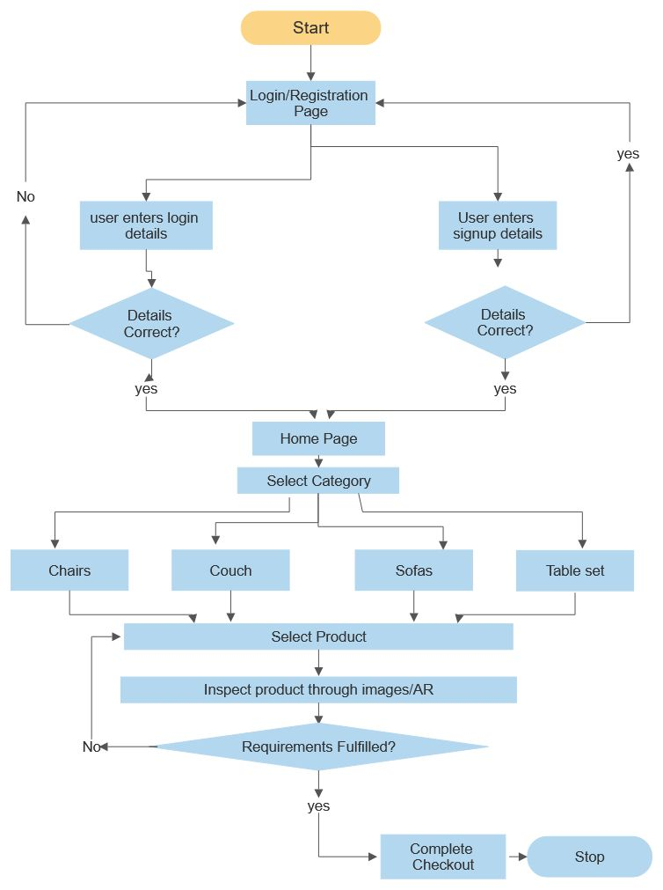

Figure 6.0: System Representation Flowchart

* After the application is downloaded from the play store, the user will be greeted with the login/registration page.
* If the user has an existing account, he/she will be able to login with their respective credentials. If the user is not registered, he/she can enter their information to signup/register.
* Upon successful login, the user will be greeted with the home page. The home page will consist of Categories of furniture from which the user can choose from. When the user selects a category, he/she will be provided with a list of products from that specific category.
* The user can then check if the product meets their requirements of certain factors such as colour/size/designs from the images and will also be able to check the layout of the particular product through their cameras on their AR enabled mobile devices.
* After the user is convinced about the product specifications and other requirements, the user can place their orders by choosing any of the payment options available in the application.
* Upon successful completion of the checkout process and capturing the payment, the order will be delivered to the customer within said number of days.

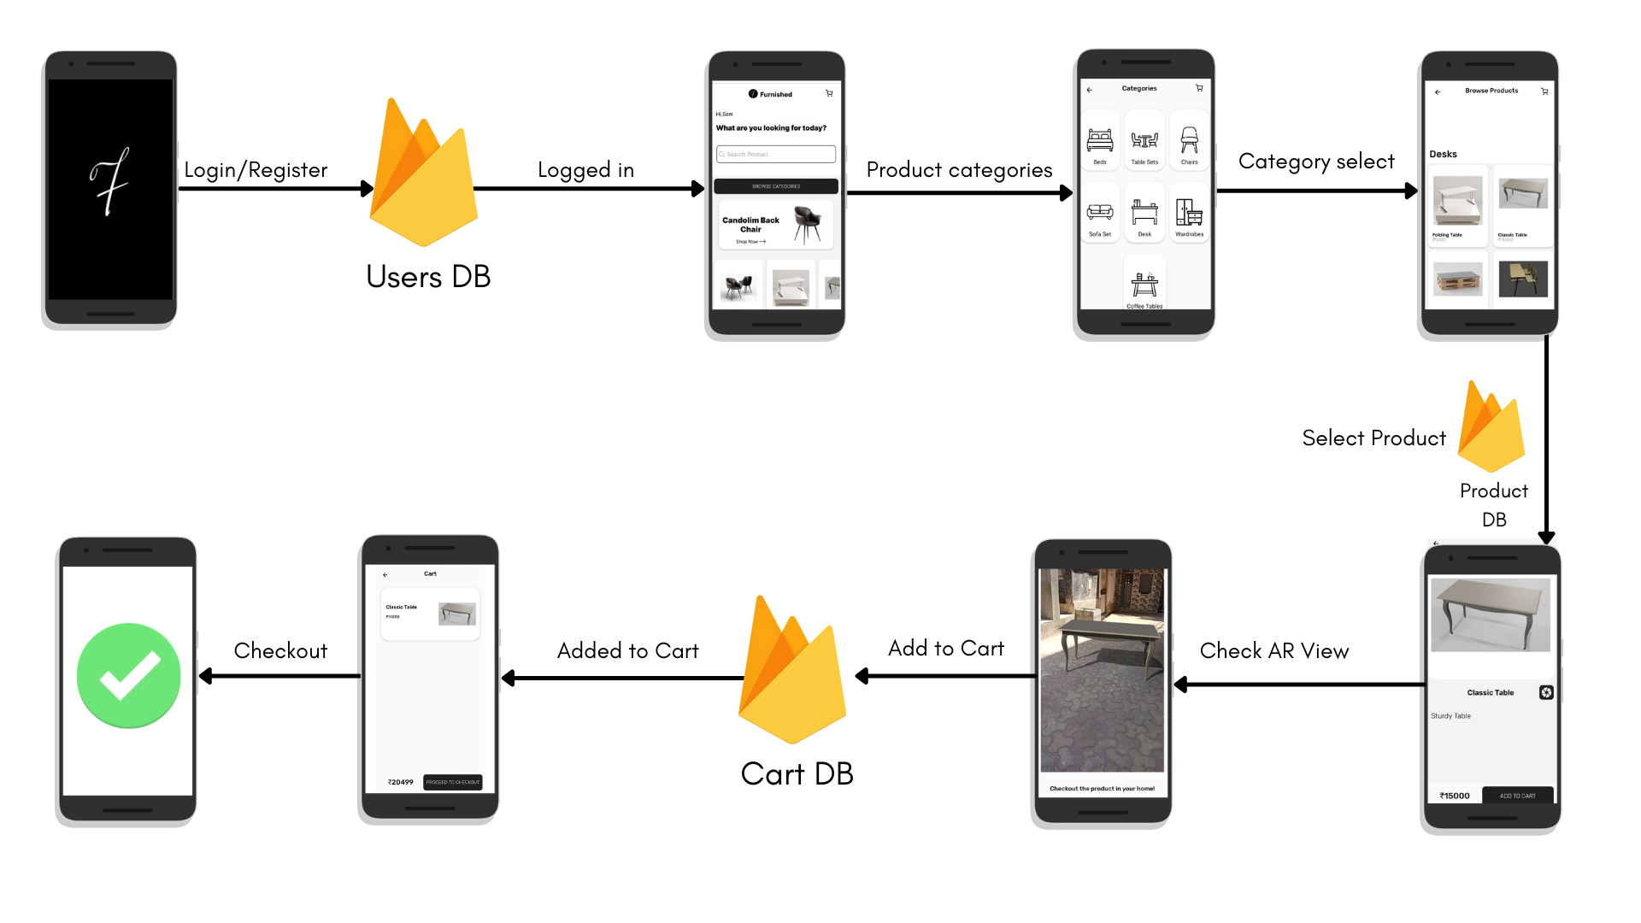

Fig 6.1 User Block Diagram

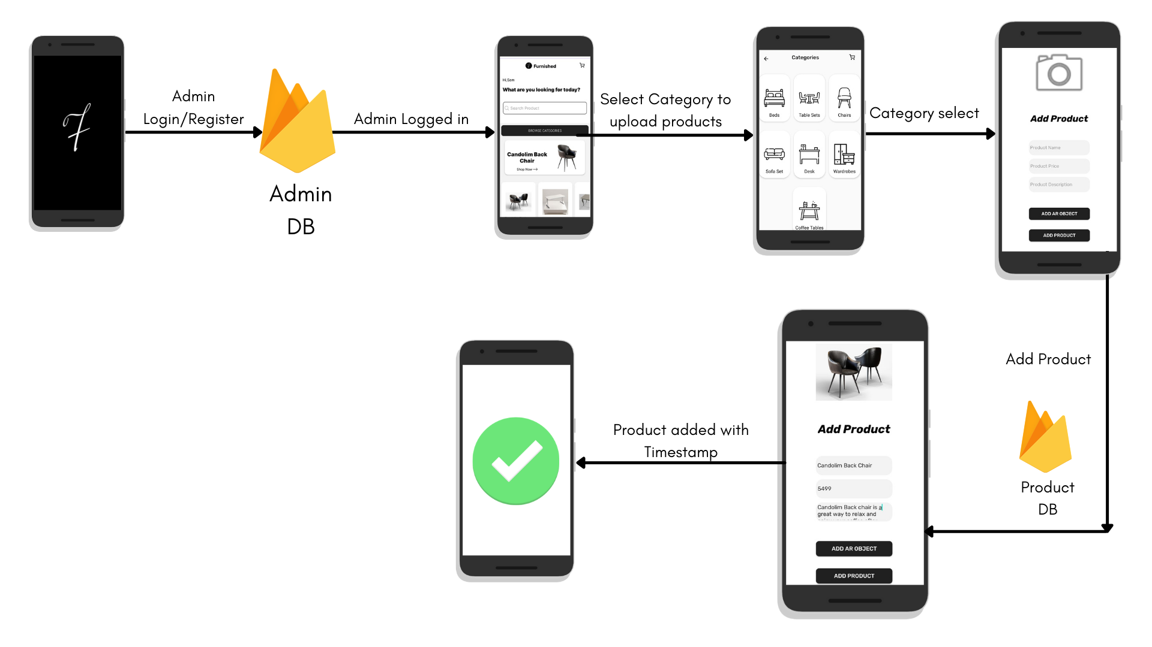

Fig 6.2 Admin Block Diagram

* Products can be added to the application only by the administrator.
* To add the product the admin must login with the phone number & password already present in the database.
* Upon successful login, the admin will be greeted with a categories screen from which he/she can select the category of the product to be uploaded.
* After selecting the appropriate category, the admin will be able to add the product name, price, description/specifications, image & Ar models in GLB format.
* After the required data is entered, the user can press the add product button to add the product to the database, where he/she will receive a notification about the product being uploaded.

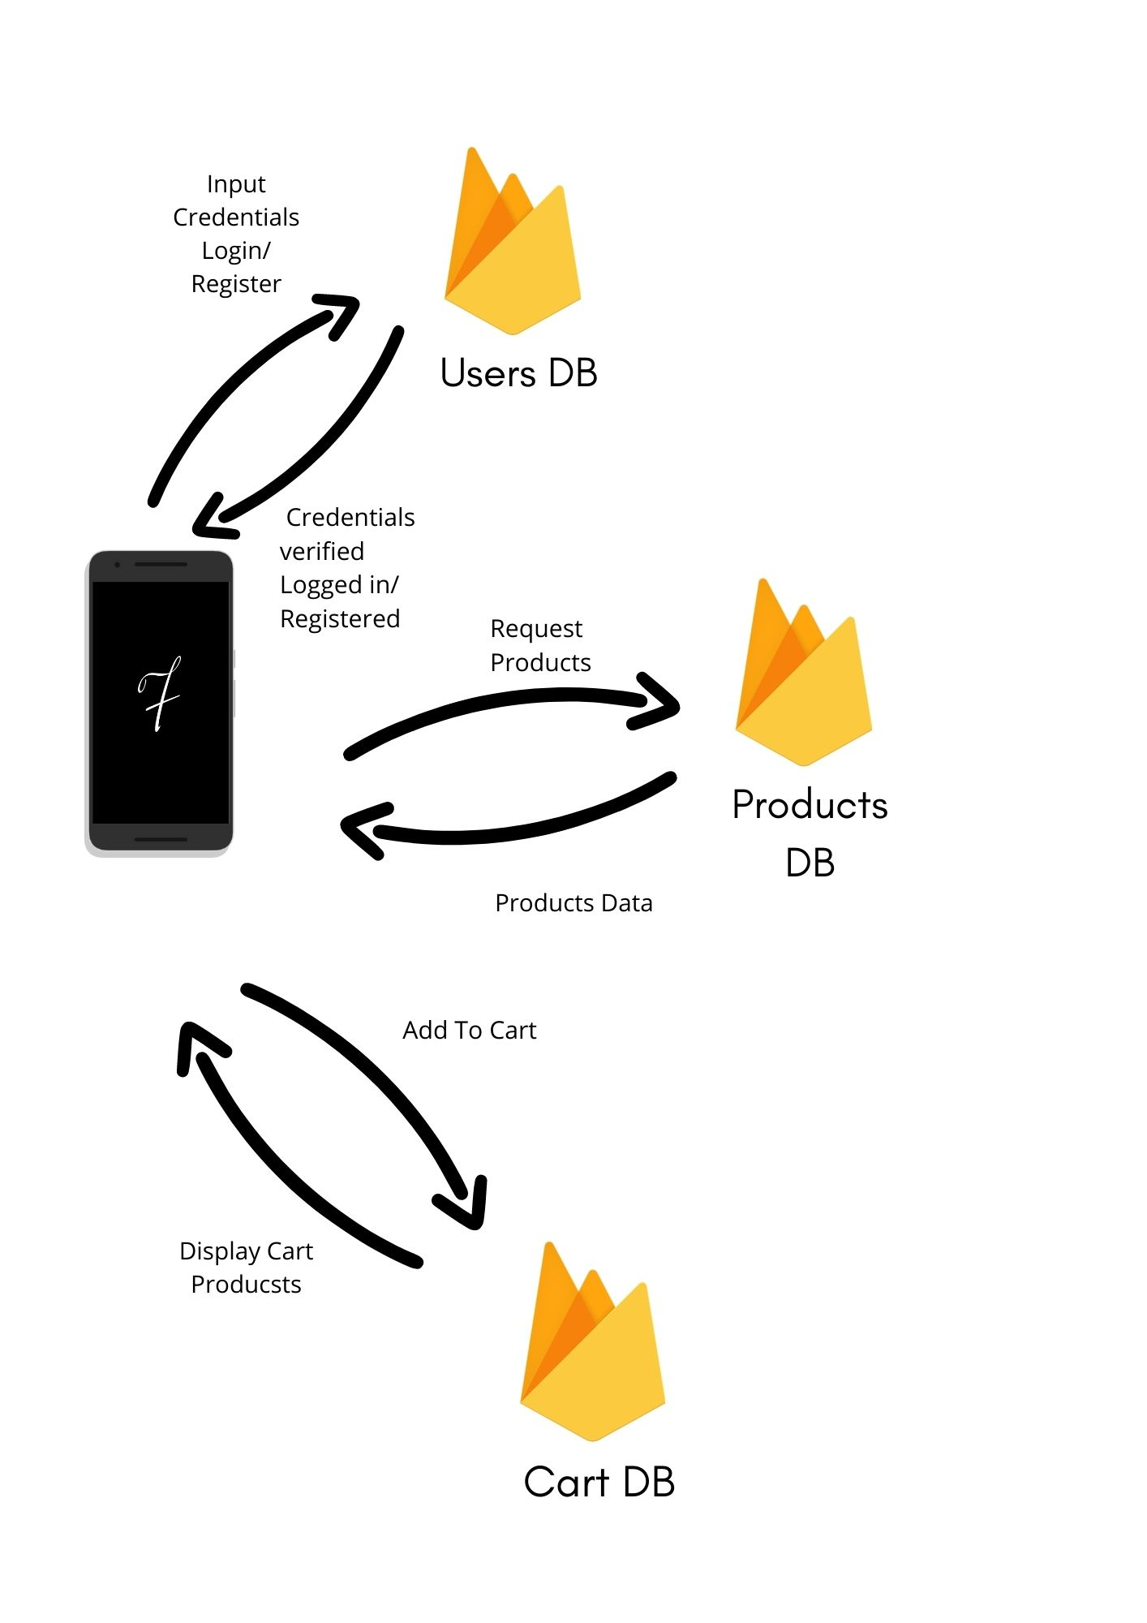Fig 6.3 System Database Representation

6.1 Components of the system

* Android Device with ArCore Support

AR core is the platform around which AR applications are built. These applications involve the use of cameras with good quality image sensors, since better quality of the cameras and sensors provide for better tracking ,scaling and general movement of the AR objects in the application.

* Realtime Database & Storage from Firebase.

The application needs a database to be linked to, in order for it to save its data on a server, and in todays’ day Firebase seems to be the best option for it since it has an easy implementation and coding process, is relatively fast & free for a certain amount of data used.

* Sceneform Plugin

The Google Sceneform Tools plugin is designed to help you work with 3D assets and the Sceneform SDK to build AR apps in Android Studio. It requires Android Studio versions 3.1 and above. It has a simple and convenient asset import flow Asset viewer, so you can see how your assets look before you deploy. It also automatically configures gradle dependencies.

* Ar Core -

It is the most important component of our system on which the application is built. It is also known as Google Play Services for AR & is a software development kit developed by Google that allows for augmented reality applications to be built on multiple platforms.

**7. REQUIREMENT ANALYSIS**

7.1 Functional Requirements

This section focuses on the functional requirements of the project. Functional requirements are the mobile devices required, the bandwidth requirement for user & products data transmission, data storing and manipulation techniques. Since the project is mainly built for android devices, the prime functional requirements are android devices with AR support and good quality cameras and their associated image sensors.

7.2 Non-Functional Requirements

Non-functional requirements can help to improve the quality of the product, but their absence will not affect the implementation. These include LIDAR sensor, which is a sensor primarily created for better autofocus in iPhone devices, but also drastically improves the quality of the ar objects perceived. Moreover, if faster databases are used for the application, we can also reduce the lag at runtime where the model is built.

**8. SCOPE AND FEASIBILITY**

8.1 Scope

The developed system has a wide range of applications. Due to the growth of the e-commerce platforms, the developed system has applications in a lot of sectors, especially in cities like Mumbai, Delhi and Bangalore. The application will provide any shopper a true sense of your product with augmented reality, which will provide a revolutionary way of shopping to any and all customers of the store.

8.2 Feasibility

8.2.1 Operational Feasibility

Operational feasibility is the ability to handle operations and supervise the process for any additional manual analysis. Most of the things will be automated and software-based hence, a single person can manage to inspect over a wide network with minimal effort.

8.2.2 Technical Feasibility

Technical feasibility involves implementing the developed system in real-life scenarios. The popularity of Augmented Reality (AR) is increasing day by day, hence programming communities are equipped with the latest libraries, which can be directly implemented in the software. Depending upon the requirement, minor modifications can be done, but overall, the existing system is quite scalable to the proposed problem without many technical obstacles.

8.2.3 Economical Feasibility

Economic feasibility is the capital centred approach. It considers the estimated cost and statistical look out of a project. When creating an ecosystem of this application on a large scale, the software required would be expensive, the money which would be needed to spend on this part is significantly important. On the other hand, computer devices with some minimum requirements are mandatory, but without knowing the exact configuration of current systems, it's difficult to estimate the tentative cost required for upgrades (if any).

8.2.4 Legal Feasibility

Legal feasibility is an assessment that investigates whether any aspects of developed system conflicts with legal requirements or any laws. Since this project is based on e-commerce & a technology that has not been used in this particular niche, dealing with legal feasibility would be a small hindrance. It is important that the project or business is following the requirements needed. including business license, patents, copyrights, certificates, tax numbers etc.

8.2.5 Schedule Feasibility

Schedule feasibility is defined as the probability of a project to be completed within its scheduled time limit. As this is an optimization system, the more time invested in enhancing the ar models and the application ui will result in the application or idea being widely accepted across various niches, since ar is not used for mainstream applications yet, but for more entertainment centered applications.

**9. METHODOLOGY**

9.1 Model Generation / Collection

There are many ways in which the models required for this project can be generated. One can try to create the models based on real furniture by using softwares like Cinema 4d, Blender etc. Since this project uses sceneform library, we used glb models since they can be packed along with all of it’s textures and colours. Moreover, they have a faster efficiency of building at runtime itself. For example purposes, we have taken some pre built open source models along with the ones that we built and used them in our application. In the future, the model generation process can be done by using a technique called Photogrammetry, which uses high definition cameras along with their sensors to create the most apt 3d model of the object in question.

9.2 UI Building

User interface is a very important aspect of this application since any customer who is an online shopper should have a pleasant experience of shopping online, which is what we are trying to achieve overall with Augmented Reality. The UI of the application is built around a similar project on a ui designing tool called Figma. The design of all the pages of the application are done on android studio itself, but the colour schemes, fonts, placement of icons, logos, cards and other elements are inspired from the e-commerce open source project on figma.

9.2.1 Modules in the application -

The application consists of multiple applications. They are mentioned below in the order of flow of control.

* Login/Registration - There are 2 modules in the app which can register the user. One of them can login or register a user and the other allows the app user to login as an administrator. For security purposes, there is no functionality for anyone to register themselves as an administrator. The admin credentials can only be generated at the database, which in this case is the firebase realtime database.
* Products - Products are added via the application itself, though they can also be added through the database. The admin is the only person authorised to add products, the admin can simply login, select the category of the product in which they want to upload their products & after entering the required data and after adding the ar object, the admin can simply press the add product button to upload it to the database. The product is added with a timestamp as it’s product id, which consists of the date on which it is uploaded, as well as the time. For eg - Apr 06, 202113:53:47 PM
* Ar View of the products - Ar objects are located in a separate folder called product AR files in the firebase storage database. While uploading, their name is set to their product id’s as above, appended at the end with a .glb just in case there is some error which renames the file while uploading. The file is fetched with it’s product id and a temp file is created, from which a model is built and displayed into the AR fragment.
* Cart - A product can be added to cart using the ‘add to cart’ button at the bottom of the product details page. Once the button is pressed by the user, the product is automatically added to cart due to its unique product id. The product will be added to a separate node called the cart view in the firebase database along with the id of the user who has added the product to cart. The product can also be removed from the cart by the ‘cart options’ menu.

**10. DESIGN DETAILS**

The design part includes the following:

a. Context Level Diagram

b. Data Flow Diagram (DFD)

c. Sequence Diagram

d. Entity Relation Diagram

e. Database design

f. Storage design

10.1 Context Level Diagram

The context level diagram represents the entire system as one high-level process and shows the relationship between different entities involved in the process. The entities involved in this project are described in the following diagram, namely, System Administrator, End user or Customer & Furnished application system/database.

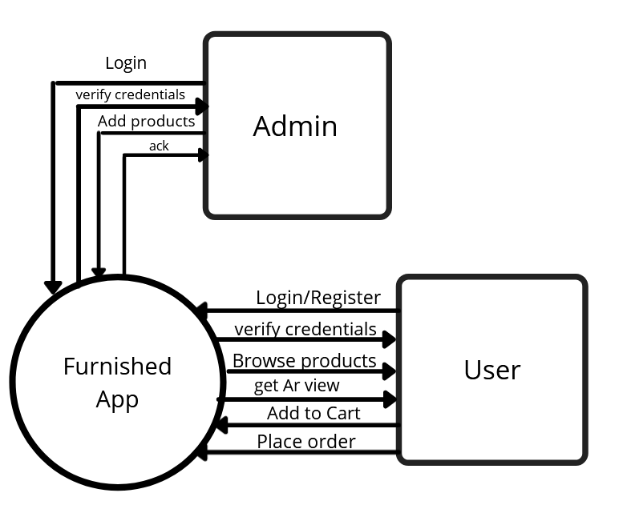

Figure 10.1: Context Level Diagram

10.2 Data Flow Diagram

A data flow diagram (DFD) maps out the flow of information for any process or system. It uses defined symbols like rectangles, circles and arrows, plus short text labels, to show data inputs, outputs, storage points and the routes between each destination. Data flowcharts can range from simple, even hand-drawn process overviews, to in-depth, multi-level DFDs that dig progressively deeper into how the data is handled. They can be used to analyse an existing system or model a new one.

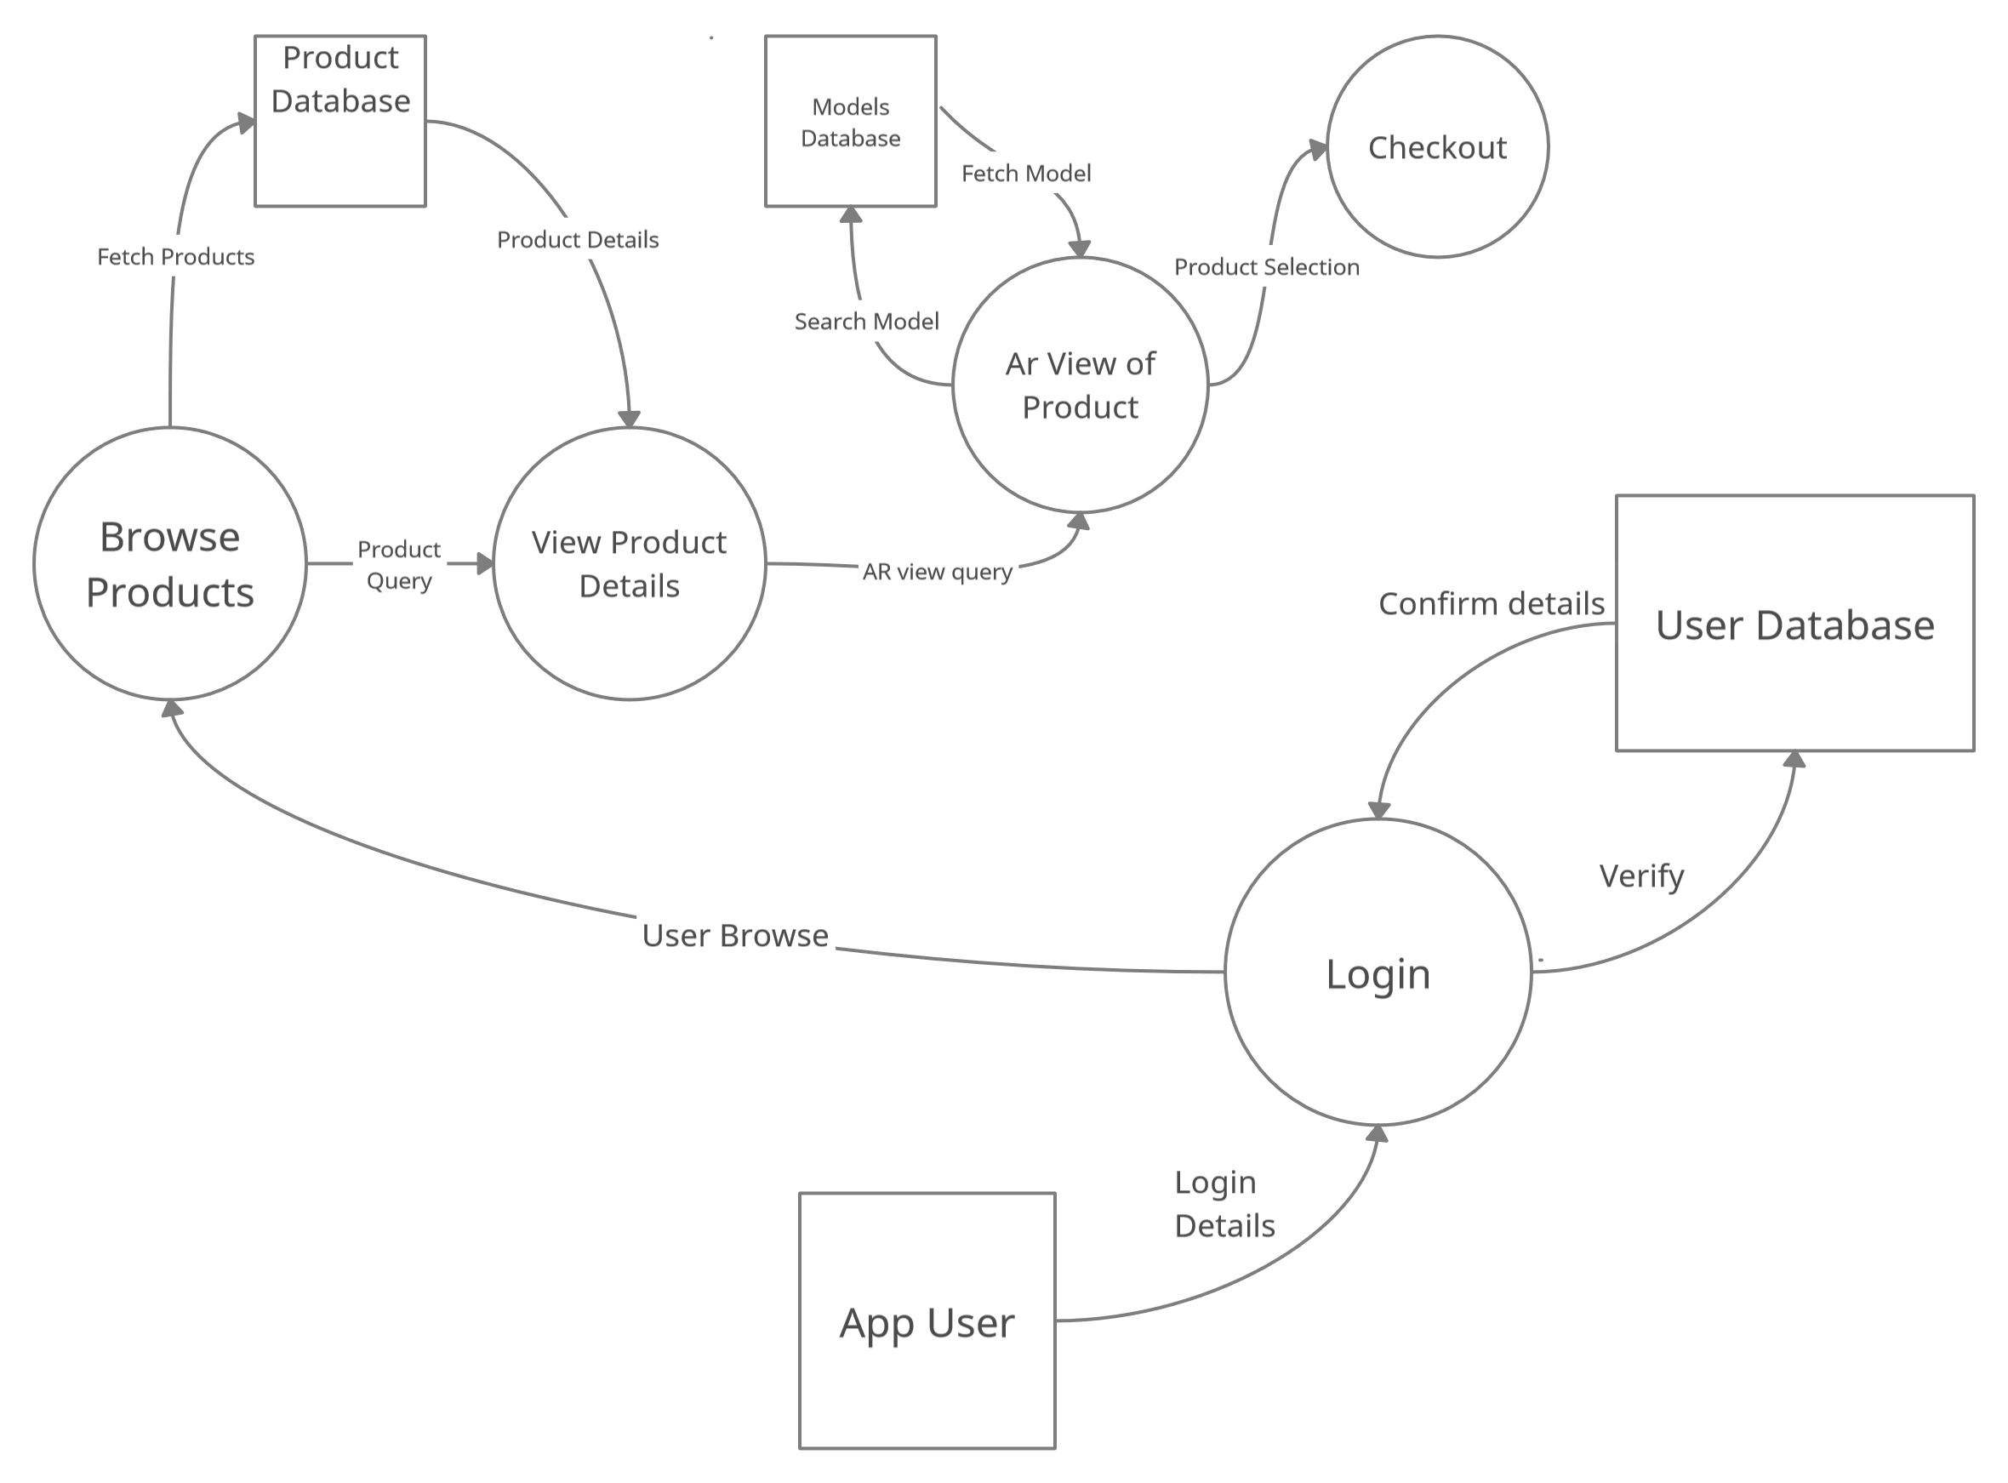

Figure 10.2: Data Flow Diagram

10.3 Sequence Diagram

In the sequence diagram, the objects according to their time of execution are listed below. The sequence diagram deals with how the user will flow through the system sequentially and what are the processes that will take place. As seen in the figure, there are multiple get and post requests taking place to the database for access to the UI as well as the product information.

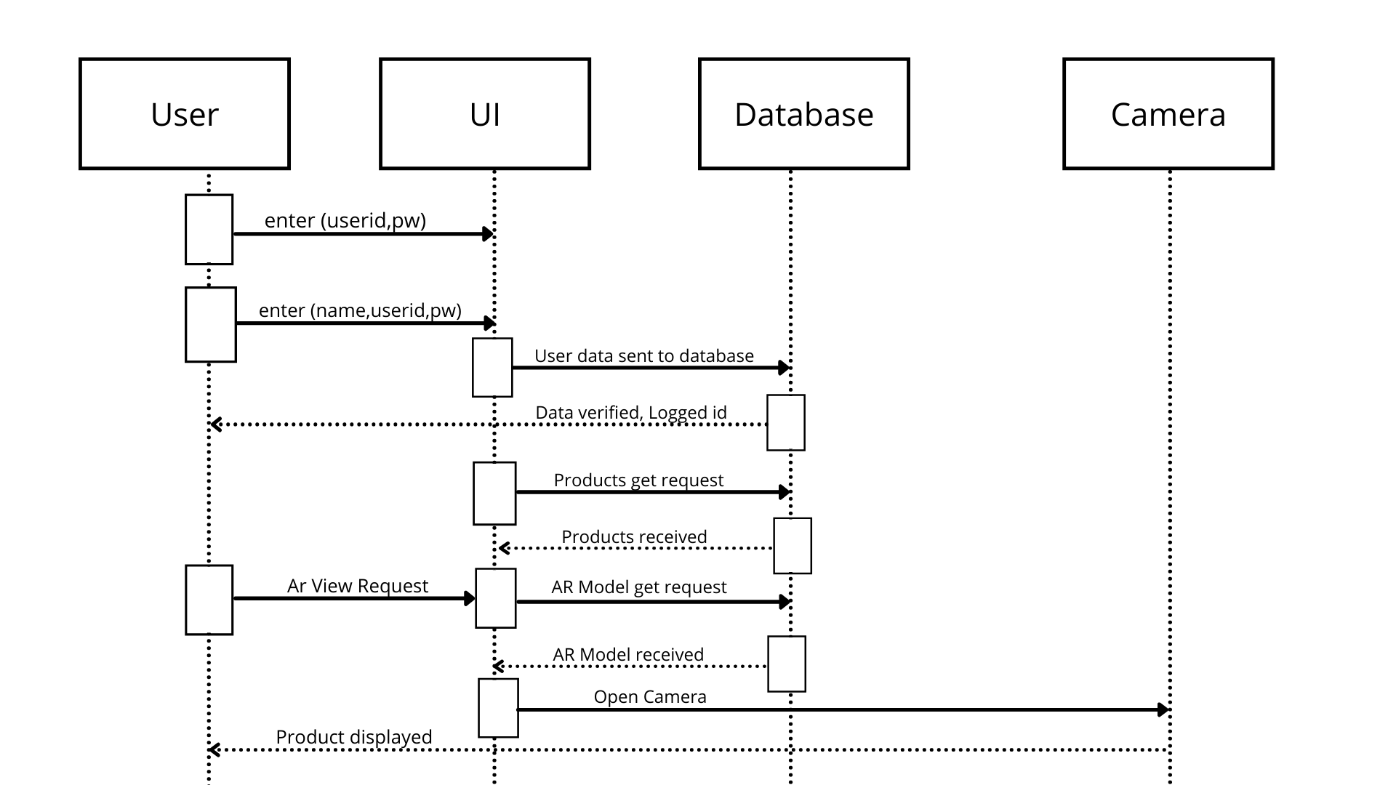

Figure 10.3: Sequence Diagram

10.4 Entity Relation Diagram

The main entities and how they are related to the other is shown in the diagram below. The entities and their key attributes are defined and what entities are interacting with each other for what purposes.

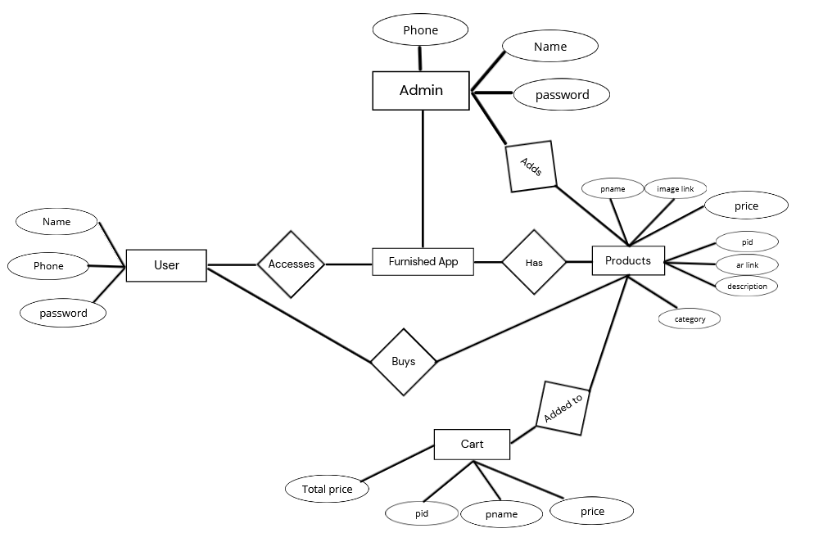

Figure 10.4: Entity Relation Diagram

10.5) Database Design

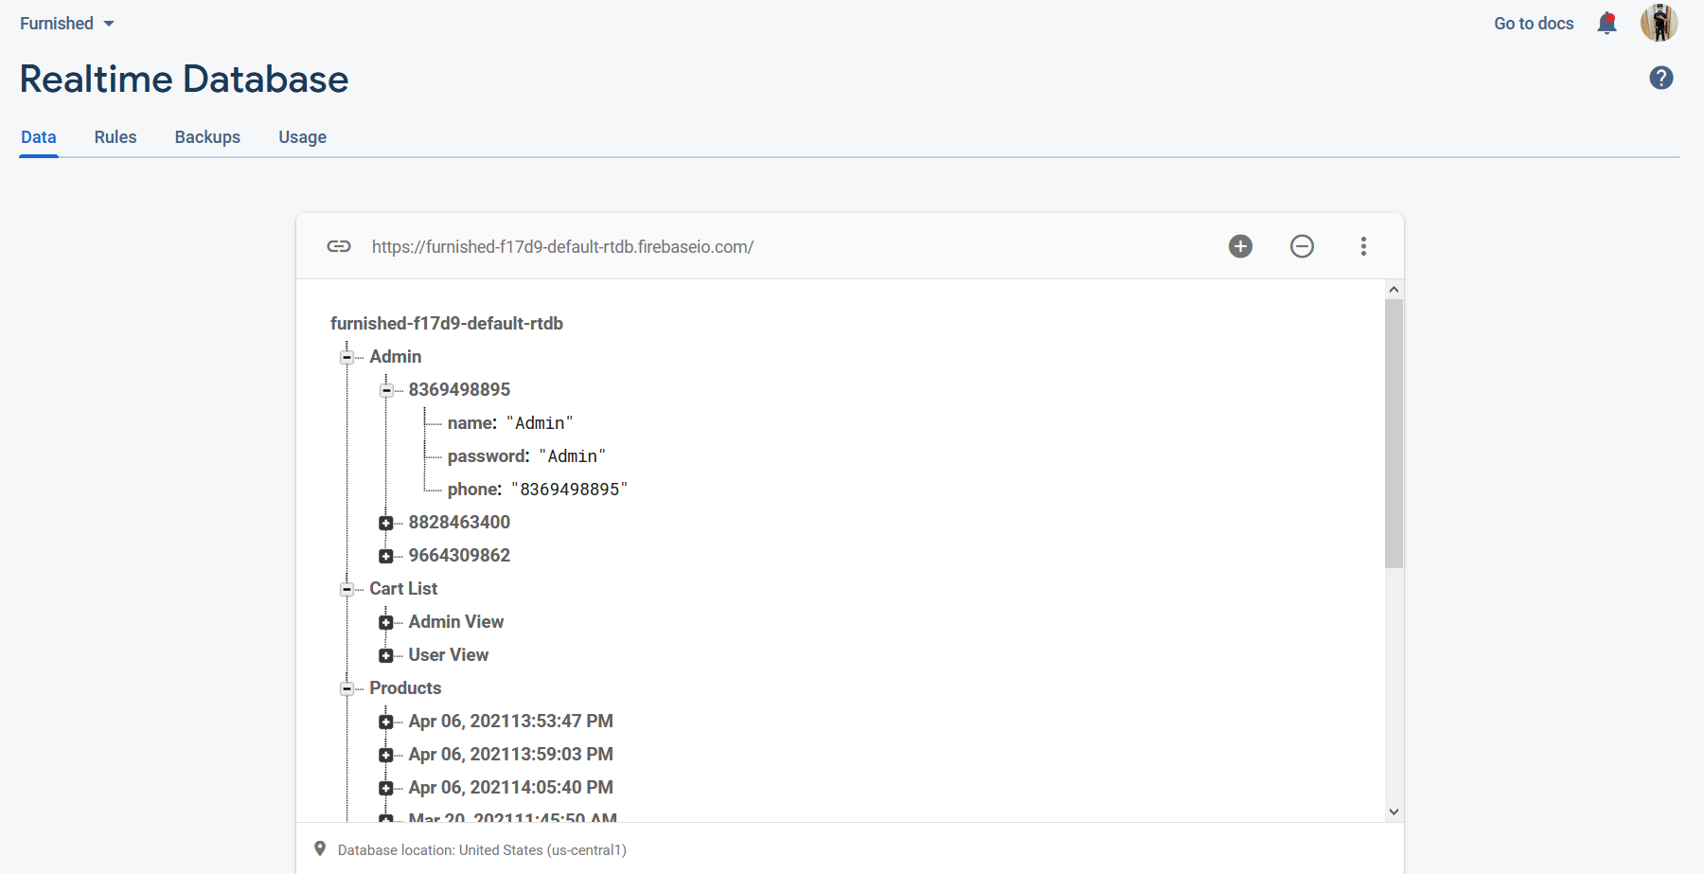

Overall Database Design

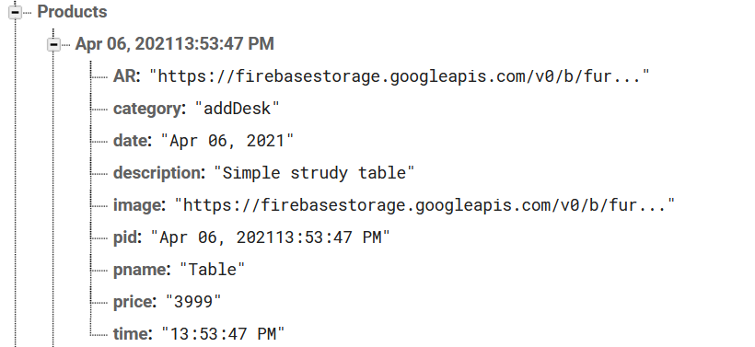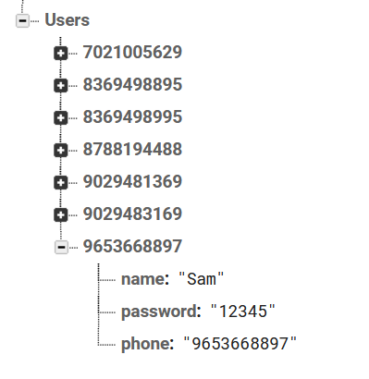

Products Node

Users Node

Figure 10.5: Database Design

10.6) Database Storage

Figure 10.6: Database Storage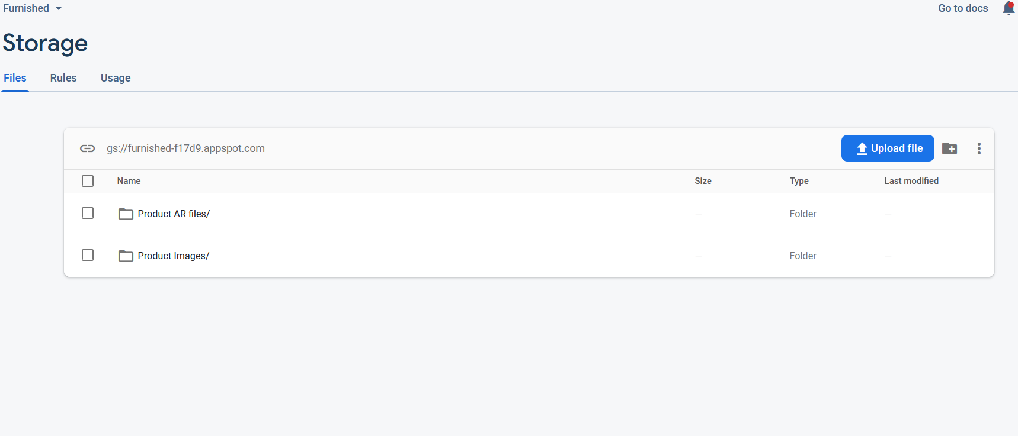

**11. IMPLEMENTATION AND EXPERIMENTAL SET UP**

11.1 Hardware Requirements

Operating Systems: Windows 10 or Ubuntu

System RAM: 8 GB

System ROM: Preferably cloud storage or 1TB per slot

System GPU: Minimum GTX 710 or equivalent, Recommended GTX 1650 or higher

System Processor: Intel i5 or higher

Bandwidth Requirement: 5.0 GHz up to 1GBPS transmission rate

11.2 Software Requirements

Programming language/Environment: Android Studio 3.6.3 and above , minimum Target api 24

Gradle Dependencies: ARCore, Sceneform, Firebase, Picasso, recyclerview, cardview

* Database: Firebase
* Language: Java , XML
* Designing Tools: Adobe Photoshop, Figma, Canva

11.3 Operational Requirements

Paid Databases like AWS, Google Cloud Storage or Firebase with Spark plan.

High Quality android cameras with great autofocus sensors

Apple iphone 12 with Lidar sensor

Photogrammetry equipment for extremely high quality 3D models.

11.4 Pseudo Code

11.4.1 Pseudo Code for Users:

Step 1: If already registered goto step 3 else continue

Step 2: Register

Step 3: Login

Step 4: Browse Categories

Step 5: Select Category

Step 6: Browse Products

Step 7: Select Product

Step 8: Open Ar View

Step 9 : Add to Cart

Step 10 : Checkout

11.4.2 Pseudo Code for Admin:

Step 1: Login

Step 2: Browse Upload Categories

Step 5: Select Upload Category

Step 6: Add Product details

Step 7: Add Ar objects

Step 8: Upload Products

Step 9 : Receive Ack

11.4.3 Java Method for Login: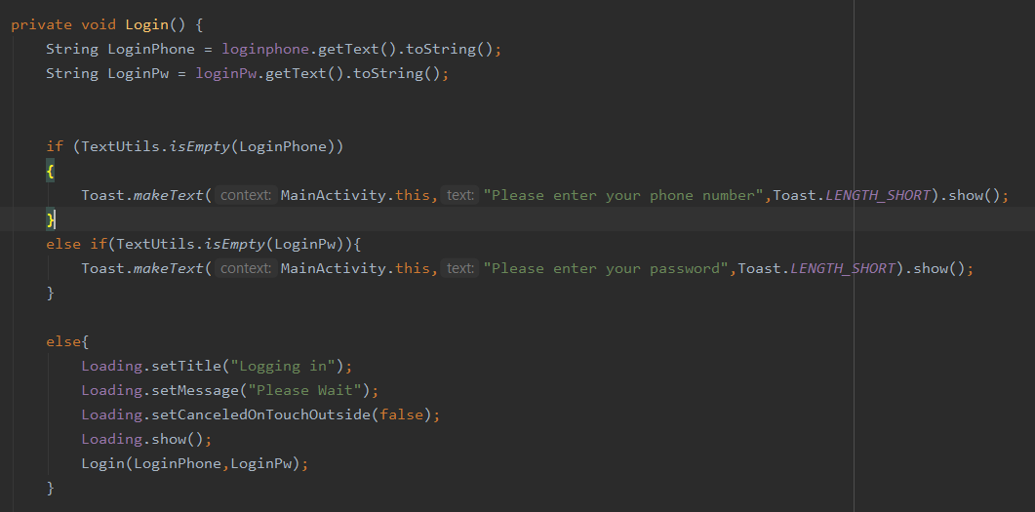

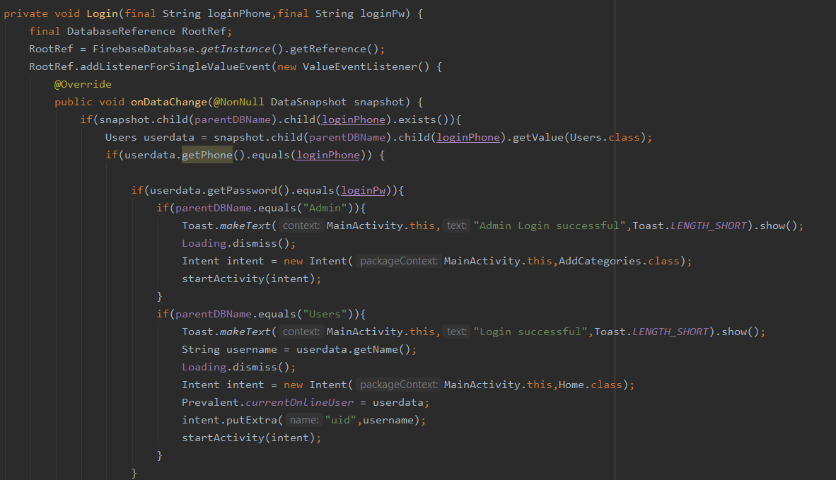

11.4.4 Java Method for Registration: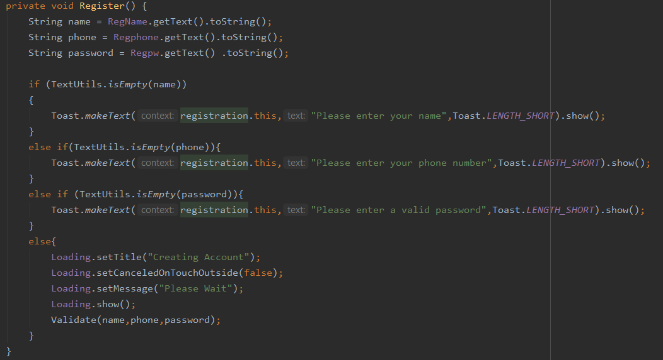

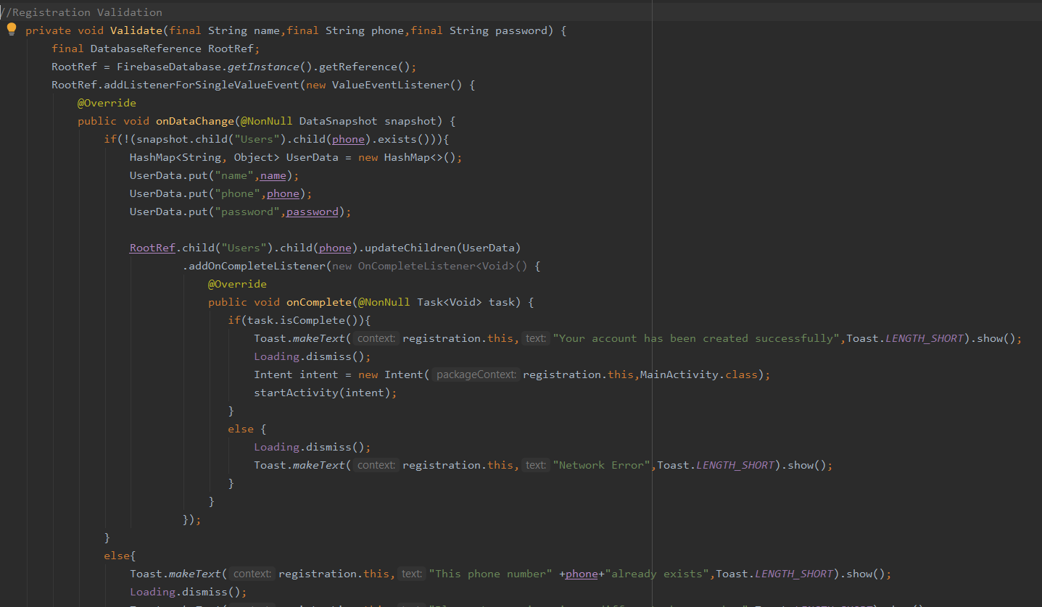

11.4.5 Java Method to get products: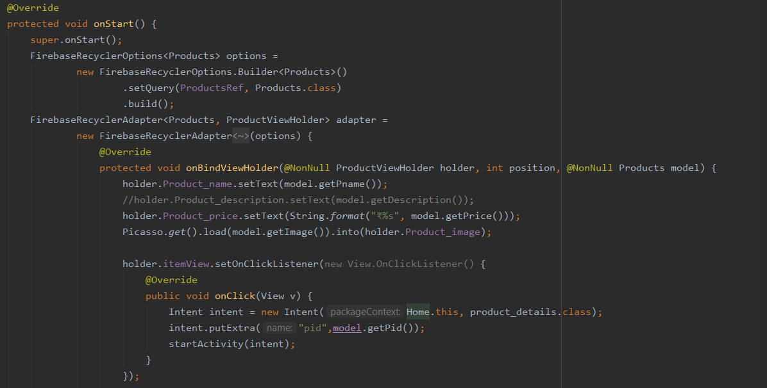

11.4.6 Java Method to get product details: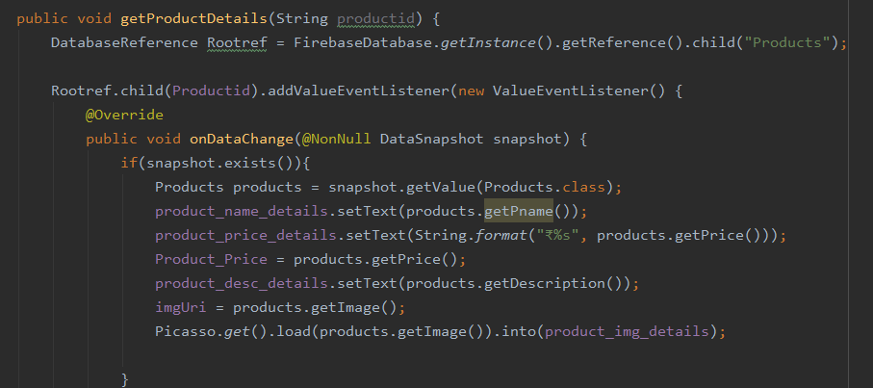



11.4.7 Java Method to put product into the cart: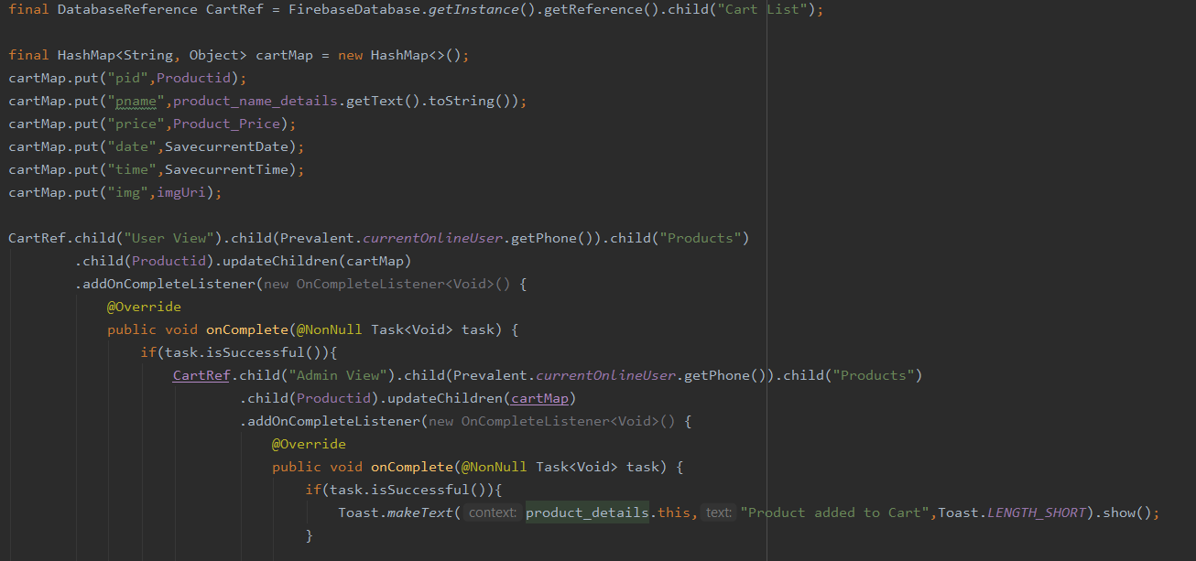

11.4.8 Java Method to display Ar model: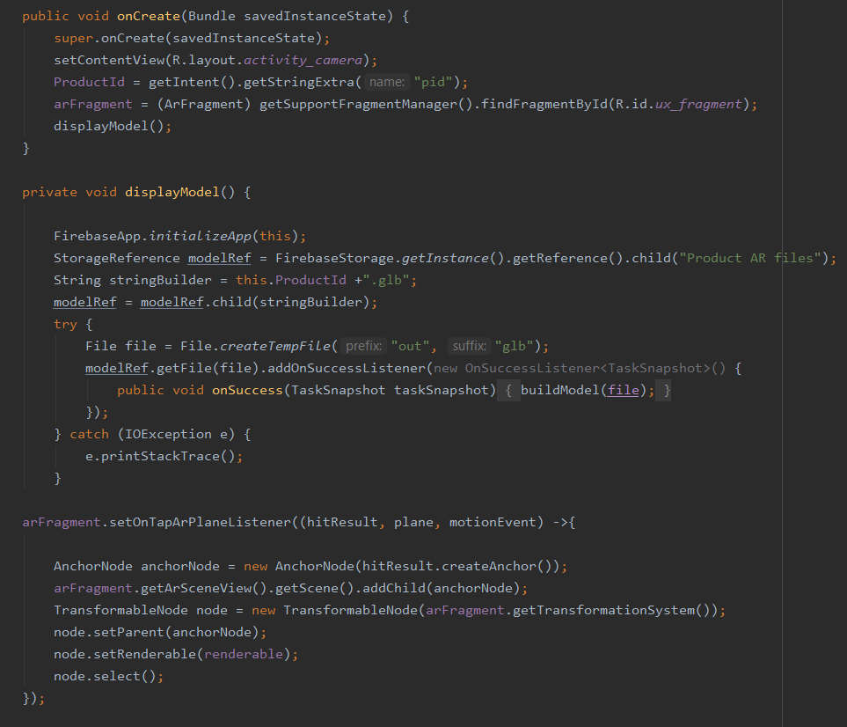

11.5) Simulation and Working Environment:

The working environment for this application is Android Studio. Development of the application was done on Android Studio with Java as the language and XML for designing. The simulation was done both on emulators and actual Android devices to check compatibility with android target apis and to clear dependencies related issues.

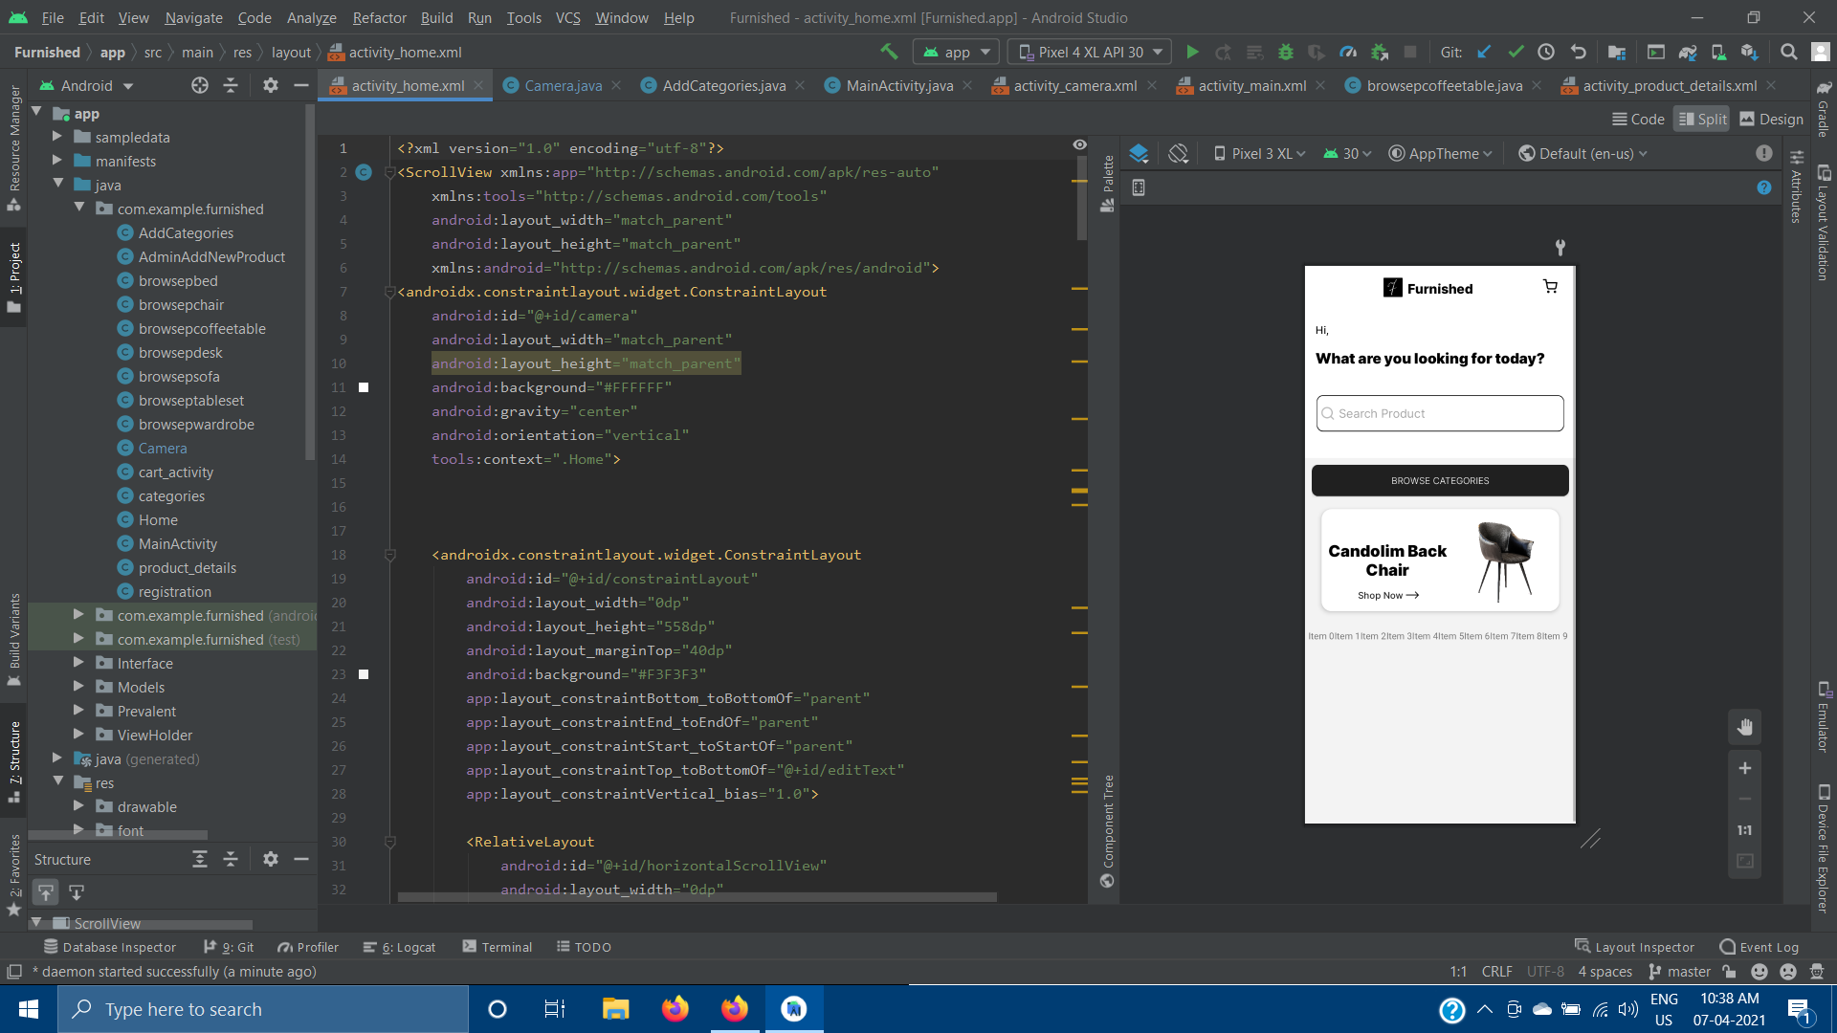

Figure 11.1: Working Environment

11.6) Gantt Chart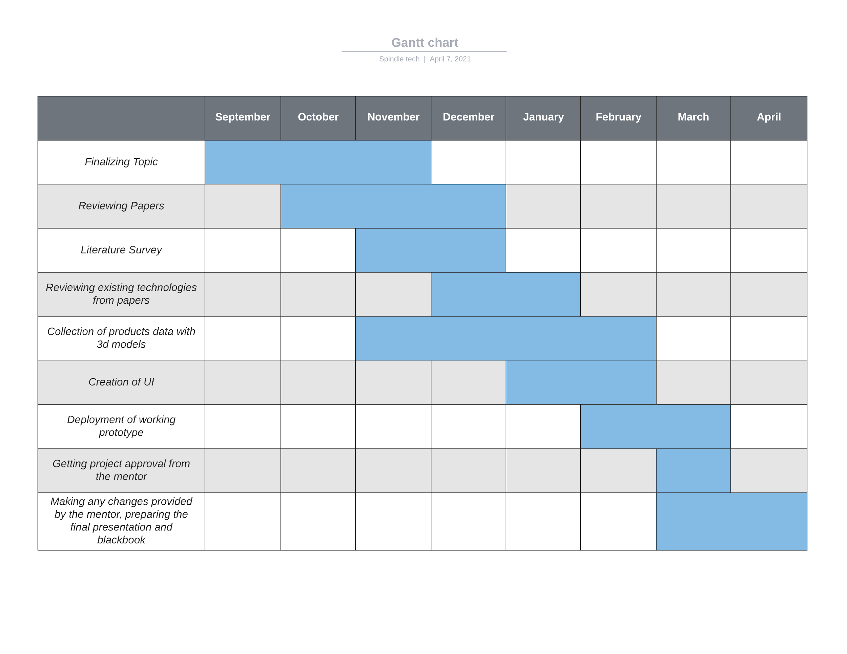

Figure 11.2: Gantt Chart

**12. TESTING**

12.1 Verification Testing

Verification is a static practice of verifying documents, design, code and program. It includes all the activities associated with producing high quality software: inspection, design analysis and specification analysis. It is a relatively objective process. Validation is the process of evaluating the final product to check whether the software meets the customer expectations and requirements. It is a dynamic mechanism of validating and testing the actual product.

12.2) Test Cases (Test table and screen shots)

1)Test Objective : User Registration

|  |  |  |  |  |
| --- | --- | --- | --- | --- |
| Test ID | Test Scenario | Input Specification | Outcome | Pass / Fail |
| 1 | Successful Registration, Data added to DB | User Details:Name, Phone number & password | Registration Successful,Toast message,Data reflected in database. | Pass |
| 2 | Unsuccessful Registration | User Details:Name, Phone number & password | Error toast message -  “Registration failed, please enter required details” | Pass |

Table 1: Registration Test

2)Test Objective : User /Admin Login

|  |  |  |  |  |
| --- | --- | --- | --- | --- |
| Test ID | Test Scenario | Input Specification | Outcome | Pass / Fail |
| 1 | Successful Login | User Details: Phone Number, Password | Login Successful,Toast message, Home page opened(user), Categories page opened (admin). | Pass |
| 2 | Unsuccessful Login | User Details: Phone Number, Password | Incorrect details Toast message, prompted to try again | Pass |

Table 2: Login Test

3) Test objective: To test the data get requests from the database.

|  |  |  |  |  |
| --- | --- | --- | --- | --- |
| Test ID | Test Scenario | Input Specification | Outcome | Pass / Fail |
| 1 | Data request | Product id (pid) | product data requested from the database, recycler view inflates the product layout activity created with the correct details. | Pass |
| 2 | Data request by category | Category Name | Data is received from database by it’s unique category key, when a category is selected from the multiple categories | Pass |
| 3 | Get Product Image | image link to storage | Product image received by picasso plugin, displayed in the product pages. | Pass |
| 4 | Get Glb model | Ar model link to storage | Product Model received by sceneform plugin, displayed in the ar fragment. | Pass |

Table 3: Date Get request test

4) Test objective: To test the data put requests from the database (Admin).

|  |  |  |  |  |
| --- | --- | --- | --- | --- |
| Test ID | Test Scenario | Input Specification | Outcome | Pass / Fail |
| 1 | Product successful upload | pname, price,description, arlink, imagelink, pid | Product data reflected in database,  product uploaded message displayed | Pass |
| 2 | Product upload  unsuccessful | pname, price,description, arlink, imagelink, pid | Error message displayed - “Please enter all the details”/”Product image/ar model is mandatory” | Pass |

Table 4: Data Put Request Test

5) Test objective: To test the displayModel method.

|  |  |  |  |  |
| --- | --- | --- | --- | --- |
| Test ID | Test Scenario | Input Specification | Outcome | Pass / Fail |
| 1 | Building model successful, Model Displayed | Pid, Product Ar object link | Model Built message displayed, model visible on ar fragment. | Pass |

Table 5: Ar Model Test

**13. RESULT ANALYSIS**

**13.1. Sample Screenshots**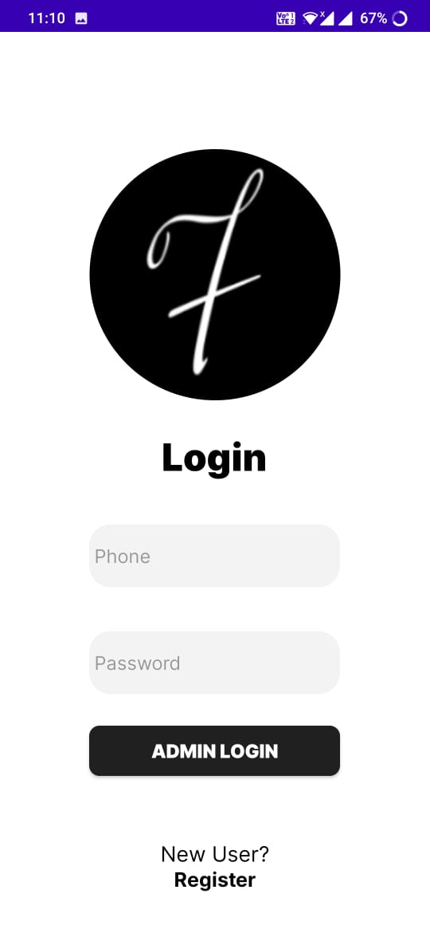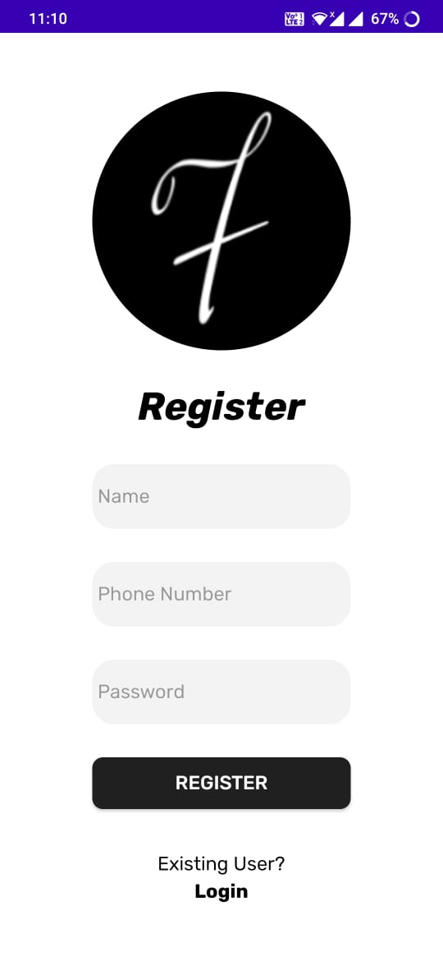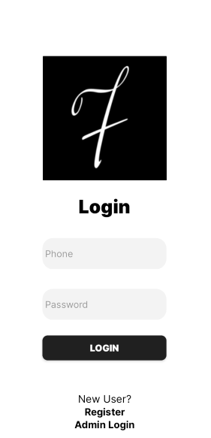

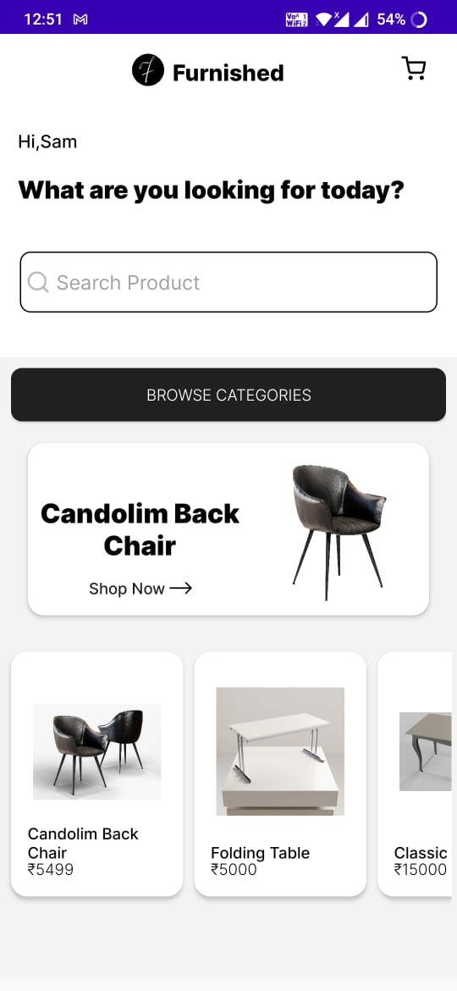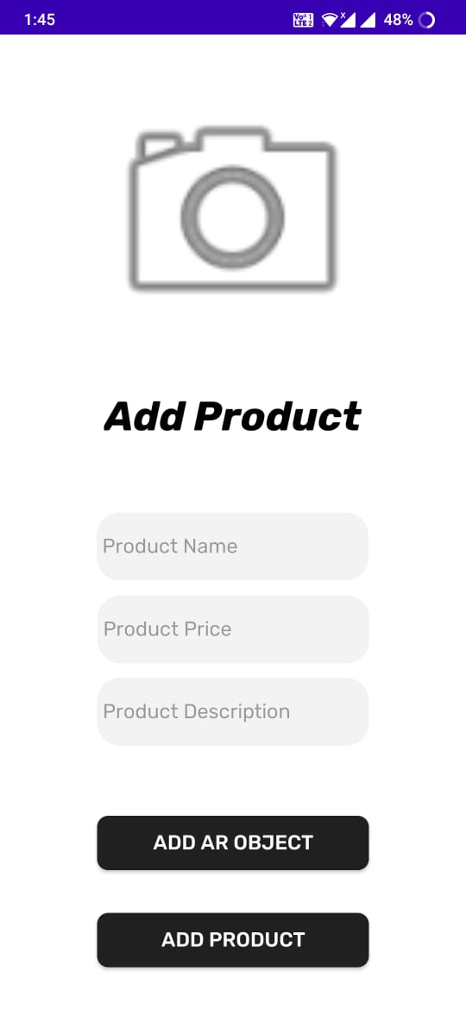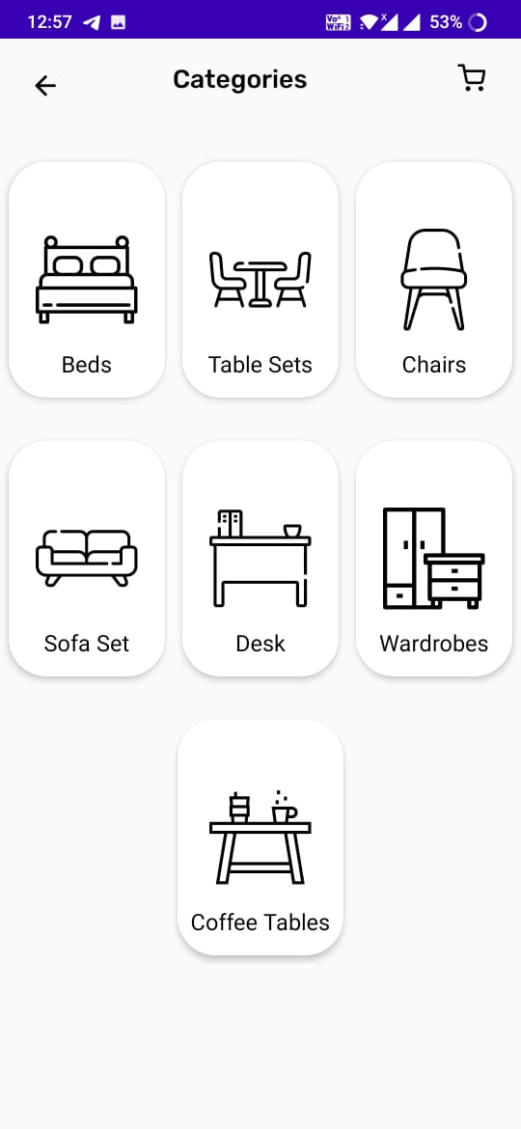

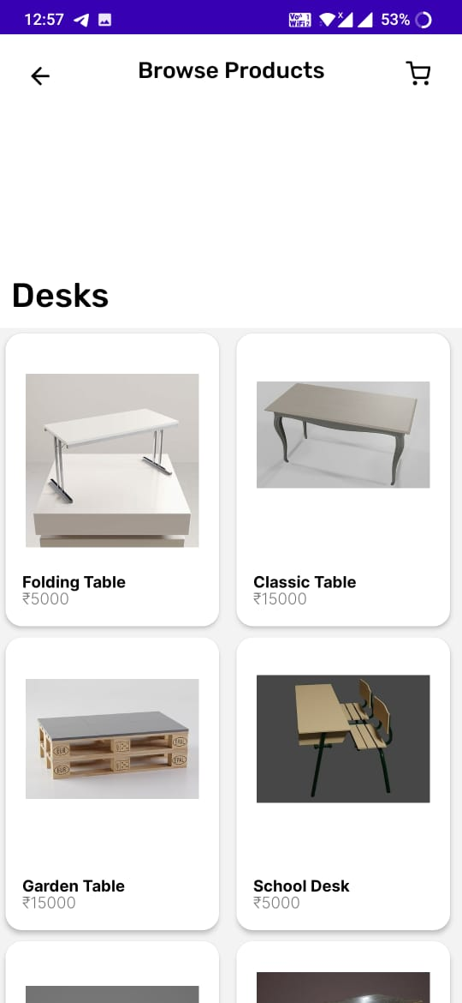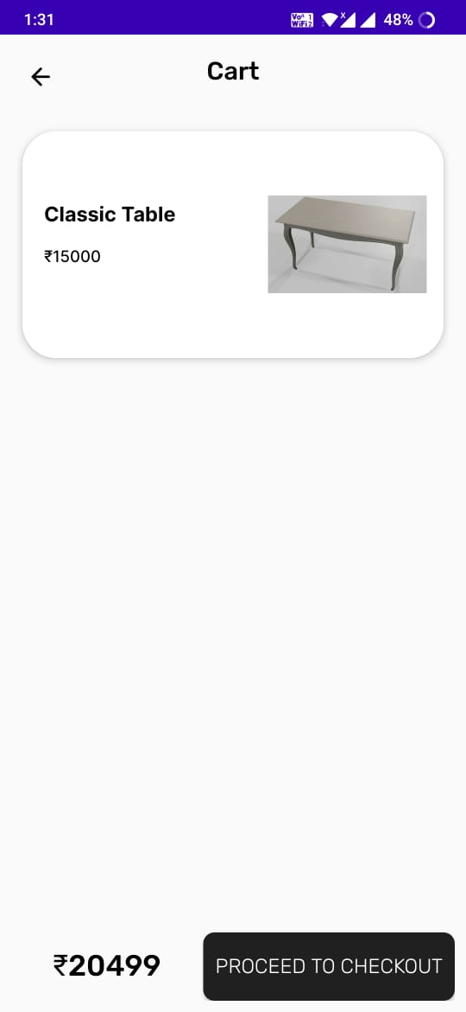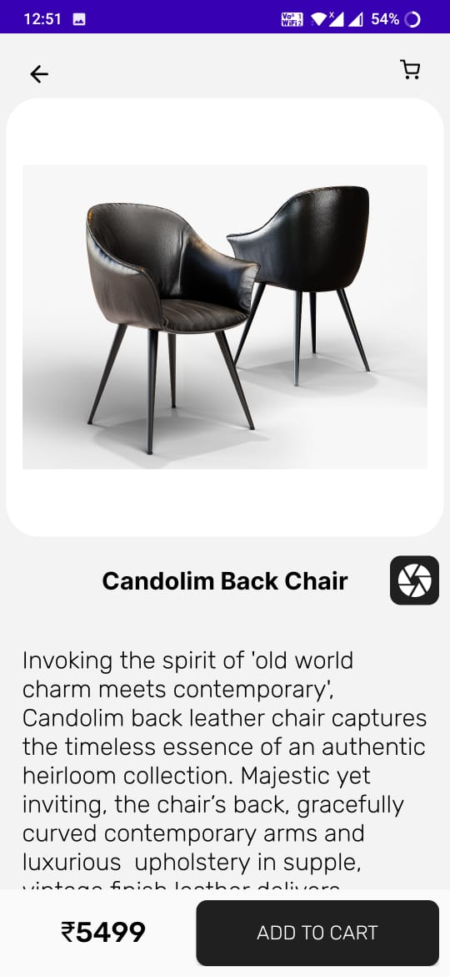

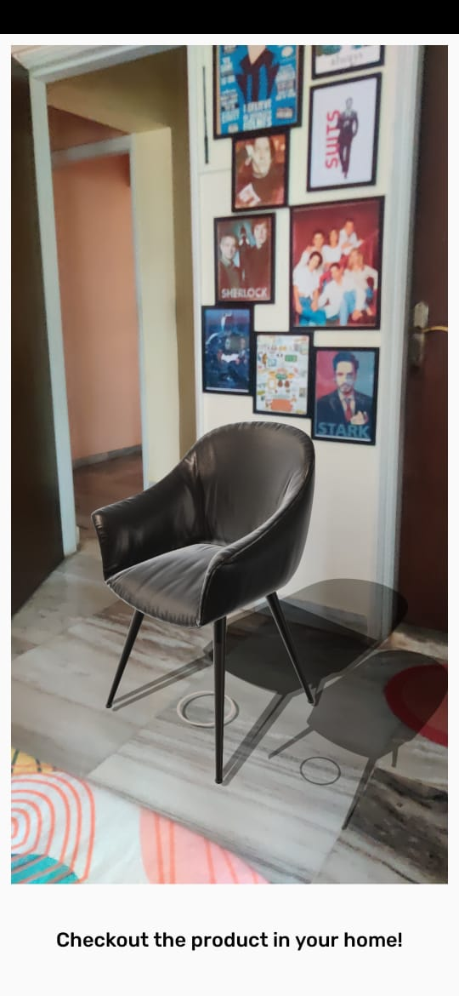

**14. ADVANTAGES AND LIMITATIONS**

14.1 Advantages

* This application essentially solves the problem regarding the fact that a product cannot be put into its place without actually buying it.
* By the way of Ar, people would be able to actually experience the product as mentioned in the applications, which would be a huge factor to increase the market share of any e-commerce furniture chain.
* None of the applications of furniture e-commerce stores in India have the functionality as in the furnished app, which gives us an advantage of revolutionizing the furniture sector.
* Creation of models and most of the functionality of the application is inexpensive, which plays a vital role in getting any major market players to implement it in their stores.
* Database used in this application is free of cost, which helps a lot for testing and debugging with moderate amounts of data.

14.2 Limitations

* A significant disadvantage of augmented reality is that it requires the collection, generation, and analysis of large sets of data. Thus, similar to the drawbacks of Big Data, it is also haunted by issues concerning privacy and security.
* The game Pokémon Go demonstrated the drawbacks of AR. Because it adds virtual information to the natural environment, AR can hide cues in the real world. Some of these cues naturally help individuals avoid dangers. Nevertheless, the technology can make an individual less vigilant about his or her surroundings.

**15. APPLICATIONS AND FUTURE ENHANCEMENTS**

15.1 Applications

* Use of this application will enable the user to visualize how the furniture would look in the real world, offering preview of furniture in one’s real environment.
* The developed system has a wide range of applications, in multiple business industries.
* Due to the growth of the e-commerce platforms, The developed system has applications in a lot of sectors, especially in cities like Mumbai, Delhi and Bangalore.
* The application will provide any shopper a true sense of your product with augmented reality, which will provide a revolutionary way of shopping to any and all customers of the store.

15.2 Future Enhancements

* AR is currently used mostly for entertainment purposes, which is hardly using the technology to its full potential. This app is created to promote the use of AR in the field of business, thus it can be extended to a lot of other industries like Textiles, Aviation, Electronics etc.
* The introduction of LIDAR sensors in iphone devices is a game changer for the mobile cameras industry, which also helps the growth of AR applications all around the world, and would increase this app’s compatibility with different types of devices.
* A technique called photogrammetry is used to create 3d models with the highest complexity and quality. Though it is currently an expensive process, we hope that there are softwares built in the future which would enable this application to add 3d models to it with the best possible quality, which can be adapted by a lot of furniture store chains.

**16. CONCLUSION**

From different ways of researching and analysing, most of the data and information convinces that AR technology is applicable not only in the architecture industry, but also sectors relating to architecture and design such as construction and visualisation.

Emerging business models and commercialization opportunities of Augmented Reality technologies is an opportunity, which we have tried to explore through this application.

The easiest way to describe the potential impact implementation of an AR application like Furnished is that it can make in any system condense it into four words: Harder, Better, Faster, Stronger. The e-commerce industry needs new technologies in order to stay relevant in the ever-changing world and be effective at realizing its mission.

**17. LITERATURE CITED**

1. Augmented Reality Web Applications with Mobile Agents in the Internet of Things-IEEE 2014 | Authors:Teemu Leppänen; Arto Heikkinen; Antti Karhu; Erkki Harjula; Jukka Riekki; Timo Koskela

2. Research on the technology of LIDAR data processing: IEEE 2018 | Authors:Dekui Lv; Xiaxin Ying; Yanjun Cui; Jianyu Song; Kuidong Qian; Maolin Li

3. Using the unity® game engine as a platform for advanced real time cinema image processing: IEEE 2018 | Author:Timothée de Goussencourt; Pascal Bertolino 4. ARKit and ARCore in serve to augmented reality-IEEE 2020 | Authors: Zainab Oufqir; Abdellatif El Abderrahmani; Khalid Satori

5. Getting started with AR development in Unity :

https://docs.unity3d.com/Manual/AROverview.html

6. ARCore overview: https://developers.google.com/ar/discover

7. Top 6 e-commerce furniture sites in india :

https://www.business-standard.com/article/companies/the-top-6-online-furniture-ec ommerce-sites-in-india-115110401480_1.html

8. Blender 2.90 Reference Manual: https://docs.blender.org/manual/en/latest/

**18. APPENDIX**

1. GLB - A binary version of the GL Transmission Format (glTF) file.
2. FBX - Filmbox file format.
3. Renderable - A Renderable is a 3D model and consists of vertices, materials, textures, and more. It can be attached to a Node and rendered as part of a scene.
4. Ar Fragment : The fragment in which the model is displayed.
5. RenderableSource class: handles loading the glTF file and creating a source object.
6. ModelRenderable: creates the renderable object.
7. Firebase Reference : Represents a specific location in your Database and can be used for reading or writing data to that Database location.
8. Node (Firebase) : Location where the database data is stored,
9. Node (ARCore) : an object that contains all the information required to be rendered on the screen.

**19. Paper Published**

**Paper Name :**

**Authors : Syamantak N.Dhavle, Chaudhary Mohammed Qais,**

**Khan Mohd Saif Tabarakallah.**

**Journal :**

**Publication Name :**